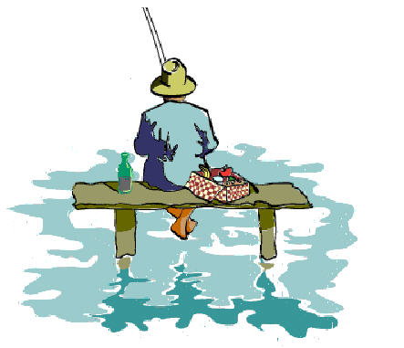

###### Alvechurch Fisheries, Little Stannalls Bittell Road, Birmingham B45 8BW

**COST**

• £9

**TIMES**

• Fishing season April- October

* Wednesday 10am-2 pm

**DELIVERED BY**

• HBS staff will be there.

Alvechurch Fisheries staff onsite to help.

**DETAILS OF ACTIVITY**

* Inform Diane Evans so a peg can be booked
* Fishing license NOT provided
* Clients who need extra support must come with 1-1 support.
* CANNOT bring own landing net. Provide by Alvechurch Fisheries.
* Full list of rules can be found : <http://www.alvechurchfisheries.co.uk/fishery-rules/>

**KNOWN RISKS**

* Can fall into the water
* Risk of the hook catching you and causing an injury
* Alvechurch Fisheries cannot accept any responsibility for injury, damage or theft to vehicles or equipment

**DIRECTIONS TO VENUE** (if difficult to find)

• Be cautious of country lanes (Hazardous bends)

**SPORTS, HEALTH & WELLBEING**

**ACTIVITY DETAILS**

Fishing