3

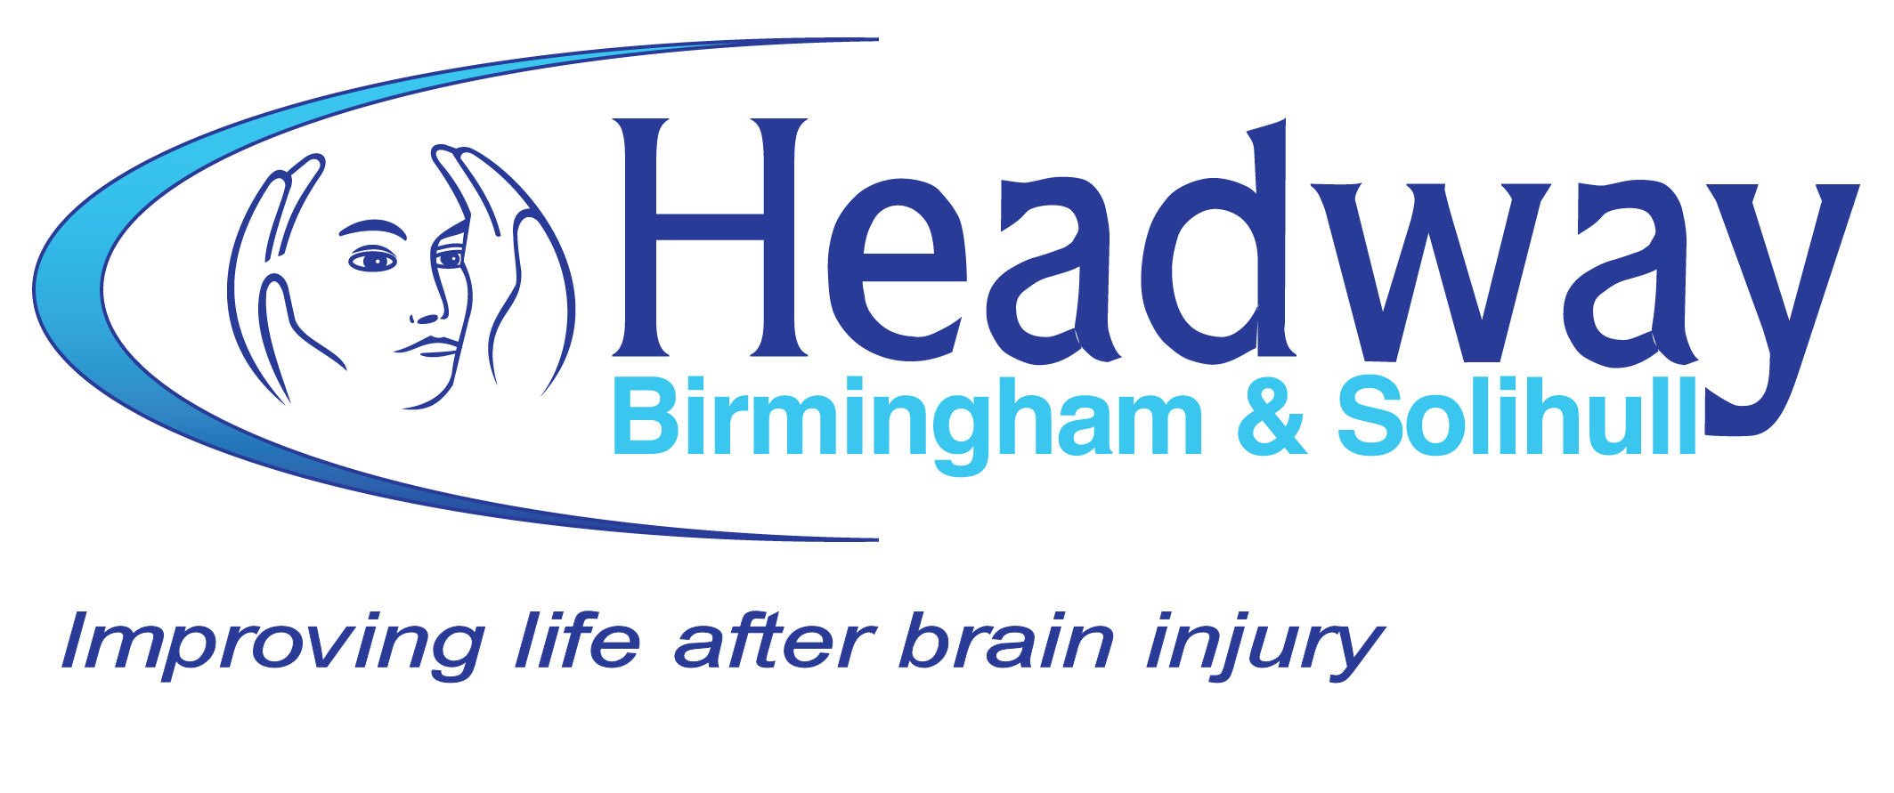

**An ‘In Memory’ donation to Headway Birmingham & Solihull is a special way to remember a loved one.**

Thousands of people each year are affected by brain injury. Headway Birmingham & Solihull provides much needed support, information and services to survivors, their families and carers.

Gifts in memory of a relative or a friend will be very gratefully received. If you would like to make an ‘In Memory’ donation, please complete and return this form to Headway Birmingham & Solihull.

The amount you donate will not be disclosed but your donation will be acknowledged with thanks.

**Thank You**

*Please make donations payable to:*

**Headway Birmingham & Solihull**

*Gift Aid will increase the value of your donation by 25% at no extra cost to you. I confirm I have paid or will pay an amount of Income Tax and/or Capital Gains Tax foe each tax year (6 April to 5 April) that is at least equal to the amount of tax that all the charities that I donate to will reclaim on my gifts for that tax year. I understand that other taxes such as VAT and Council Tax do not qualify. I understand the charity will reclaim 25p of tax on every £1 that I donate.

**Your title and name**

|  |
| --- |
|  |

**Your address & postcode**

|  |
| --- |
|  |

|  |  |
| --- | --- |
|  |  |

**Your email address**

|  |
| --- |
|  |

**I would like to make a donation in memory of:**

|  |
| --- |
|  |

**My relationship to the deceased is:**

|  |
| --- |
|  |

**Please send an acknowledgment to:**

|  |
| --- |
|  |

**Their address:**

|  |
| --- |
|  |

|  |  |
| --- | --- |
|  |  |

**Their relationship to the deceased:**

|  |
| --- |
|  |

**Enclosed is my gift of (£)**

|  |
| --- |
|  |

**Gift Aid Box* (tick)**

|  |
| --- |
|  |

**From time to time, Headway would like to contact you regarding developments in the charity or to seek your support. If you do not wish to receive future communications, please tick here.**

|  |
| --- |
|  |



# HEADWAY BIRMINGHAM & SOLIHULL

Leighton House

20 Chapel Rise

Birmingham Great Park

Rednal

Birmingham B45 9SN

[Tel: 0121](TEL:0121) 457 7541

Fax: 0121 460 1589

enquiries@headway-bs.org.uk

www.headway-bs.org.uk

If you place a notice in the press, please include the following text:

**Please make donations to**

**Headway Birmingham & Solihull**

**- 20 Chapel Rise, Rednal,**

**Birmingham B45 9SN**

*Company Registration No: 2686647*

*Registered Charity No: 1008798*

### Improving lives of those affected by brain injury



**A Gift in Memory**

Help us support brain injury survivors, their families and carers