

**SPORTS, HEALTH & WELLBEING**

**ACTIVITY DETAILS**

Lunch Clubs – Solihull and South Birmingham

Weekly Solihull Lunch Club: **Greville Arms, Sizzling Pub, Solihull, B91 2RB**

Monthly South Birmingham Lunch Club: **The Blackhorse Pub, Northfield, B31 2QT**

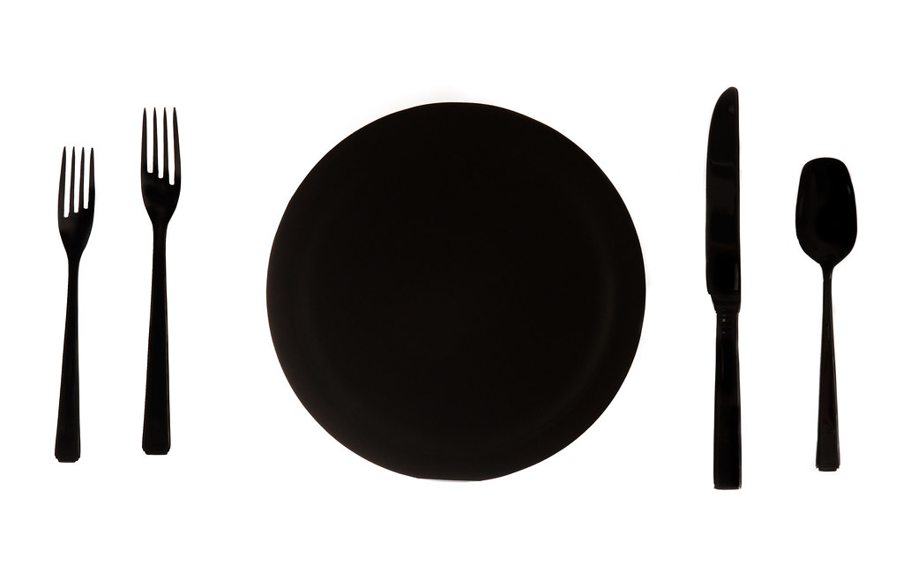

**COST**

Cost of chosen meal + donations to HBS

**TIMES**

* Solihull Lunch Club – Every Tuesday 12-2pm
* South Birmingham Lunch Club – one Friday per month (last Friday)

**DELIVERED BY**

 HBS staff attend the lunch clubs.

**DETAILS OF ACTIVITY**

* Inform Diane Evans if you are interested in taking part and then turn up
* Bring money for food and drinks
* Opportunity to meet other with a brain injury and their families.

**KNOWN RISKS**

**DIRECTIONS TO VENUE** (if difficult to find)

If driving to the Greville Arms, be sure to enter your registration number on machines inside the pub for free parking.